Local Solution Deployment
Prerequisites:
.NET 6 SDK: https://dotnet.microsoft.com/en-us/download/dotnet/6.0
An IDE: https://docs.github.com/en/desktop/configuring-and-customizing-github-desktop/configuring-a-default-editor-in-github-desktop#supported-editors
GitHub Desktop: https://desktop.github.com/download/
Docker Desktop: https://www.docker.com/products/docker-desktop/

- Clone repo in GitHub Desktop: Click on Add button and should be able to clone from your GitHub account or the repo URL.
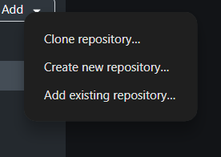
- Open with Show in Explorer: Once repo selected, click on Show in Explorer button to open in File Explorer.
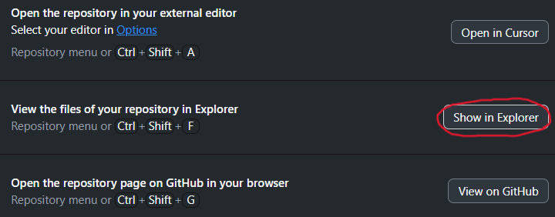
- Open in Command Prompt: Type “cmd” in the address bar and hit ENTER to open the directory in CLI.
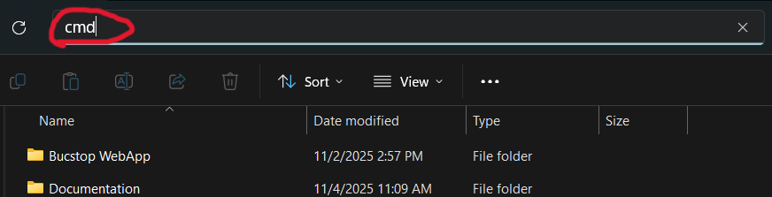
- Run Docker Compose command: Run “docker-compose up -d” Requires Docker Desktop Running
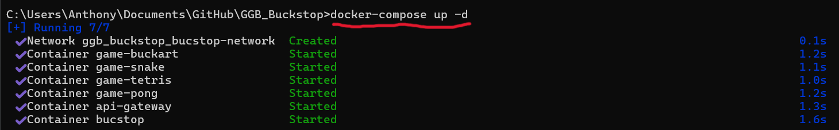
- Access the solution:
- Webapp: http://localhost:8080/
- API Gateway: http://localhost:8081/
- Snake: http://localhost:8082/
- Pong: http://localhost:8083/
- Tetris: http://localhost:8084/
- BucKart: http://localhost:8085/
Can only access the API Gateway and the games mircoservices through the Webapp. Trying to access them directly leads to 404 error code.
Docker Compose Commands: https://docs.docker.com/reference/cli/docker/compose/

